**Negative yielding debt dynamics**

18 July 2019

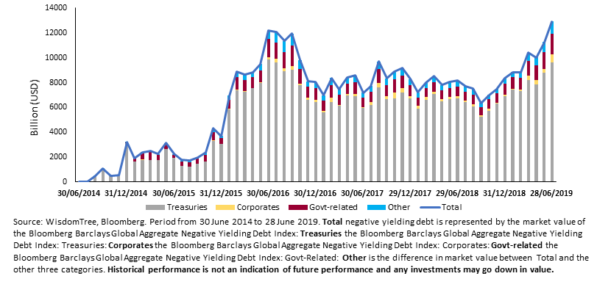

“Investors are now faced with just over $12.9 trillion in negative yielding debt outstanding, past the highs seen on 30 June 2016.  This represents a nearly 68% increase from July 2018 and is primarily driven by negative yielding government bonds as market uncertainty related to slowing global growth, trade wars and Brexit among other things drive investors into historically safe haven assets. With the market expecting the European Central Bank to further ease monetary policy with more quantitative easing or lower policy rates, we have seen a global rally in bond markets across the credit rating spectrum as investors pile into both safe haven assets and higher yielding debt, subsequently pushing yields down. We expect the amount of negative yielding debt in the market to increase, forcing investors to continue seeking yield outside of traditional fixed income asset classes and maintaining risk where appropriate within their portfolios.

“In the current environment, where yields are falling, AT1 (Additional Tier1) CoCos1 are providing an attractive yield relative to other asset classes with a yield-to-worst of 5.52% as of 1 July 2019 and only 3.33 years of duration using the iBoxx Contingent Convertible Liquid Developed Europe AT1 (Eur hedged) index as a reference. This asset class offers a solution for yield seeking investors who are comfortable with the risk/return profile when considering European high yield bonds using the iBoxx EUR liquid high yield index as a reference are currently offering 3.54% yield, 1.98% lower than the AT1 CoCo index for the same period. Even for investors who have historically taken exposure to Emerging markets, AT1 CoCos can still provide a yield pick up at the moment. Emerging market (EM) corporates are offering 3.61% yield with 5.23 years durations, EM USD Sovereigns are offering 5% with 9.42 years duration.”

1 AT1 CoCos were created to help banks meet new post-financial crisis regulations. As the most junior class of subordinated debt, AT1 CoCOs are designed to absorb a bank’s capital losses in times of financial distress. They are hybrid bonds intended to convert into equity or have their principal written off partially or wholly upon certain triggers stated in their bond documents.

**This material is prepared by WisdomTree and its affiliates and is not intended to be relied upon as a forecast, research or investment advice, and is not a recommendation, offer or solicitation to buy or sell any securities or to adopt any investment strategy. The opinions expressed are as of the date of production and may change as subsequent conditions vary. The information and opinions contained in this material are derived from proprietary and non-proprietary sources. As such, no warranty of accuracy or reliability is given and no responsibility arising in any other way for errors and omissions (including responsibility to any person by reason of negligence) is accepted by WisdomTree, nor any affiliate, nor any of their officers, employees or agents. Reliance upon information in this material is at the sole discretion of the reader. Past performance is not a reliable indicator of future performance.**